**Next Generation Fault Collector (NGen-FC)**

Fault Management: Fault Collection 🡪 Processing 🡪 Co-relation 🡪 Consumption

(1) Fault detection, (2) Fault location, (3) Restoration of service, (4) Identification of root cause of the problem, and (5) Problem resolution.

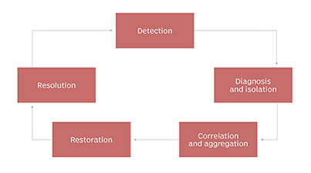

***Fault Collection As a Micro Service*** (***FCAaS***) - Need of the hour.

Applications don’t have to worry about supporting node specific MIBs

**What it is about:** Fault Collection as an independent, elastically scalable micro service, easily consumable by any application like ONAP.

Fault collector collects SNMP traps, loads MIBs and does transformation.

**What is a Fault Collector?**

* Fault Collector provides a generic way to collect Fault events generated from different sources which support private MIBs.
* It loads and translates fault information from the Management Information Base (MIBs) at Run time
* It forwards Alarm Objects to the fault receiver application

Why Next Generation Fault Collector?

* Independent Fault Management
* Easily composable in to other apps, Coexists with other apps/services
* Enables building value specific apps that can consume it
* Elastically scalable for ever growing needs
* Easier to integrate any 3PP MIBs ->Minimal manual intervention
* Uses lightweight /modern stack -> Cloud native principles

**High level architecture**

**Transformation Engine:**

* Dynamic loading of MIBs + Xml
* Converting traps to serialized O/P